**Deep Learning Lab WS1819 – Exercise2 Report**

Objective of this exercise was to implement a Convolutional Neural Network for MNIST classification task using TensorFlow library. There were many options available to implement a CNN using TF library including recent high level Keras API, Estimators and to more traditional ways to implement neural networks using TF. To get a better understanding of TF library I chose the latter.

**1-Implementing a CNN in TensorFlow:**

The following results were observed for validation loss and training loss after 100 epochs with batch size of 128 and initial settings of the network.

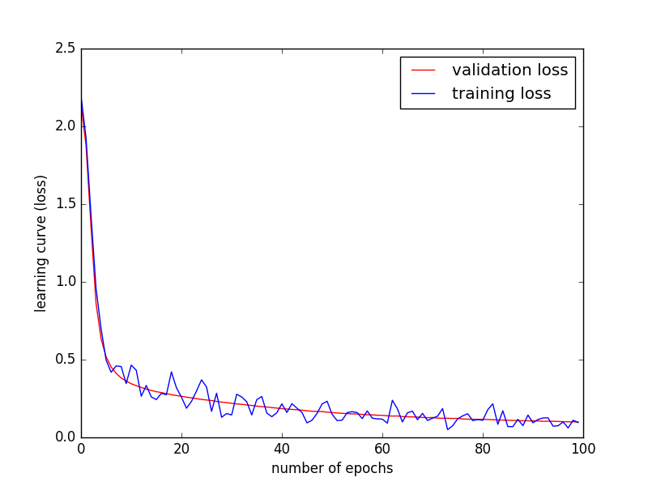

**2- Learning Rate**

The following results were observed for validation loss after 100 epochs with batch size of 128 and initial settings of the network except this time learning-rate was changed from 0.1 to 0.0001

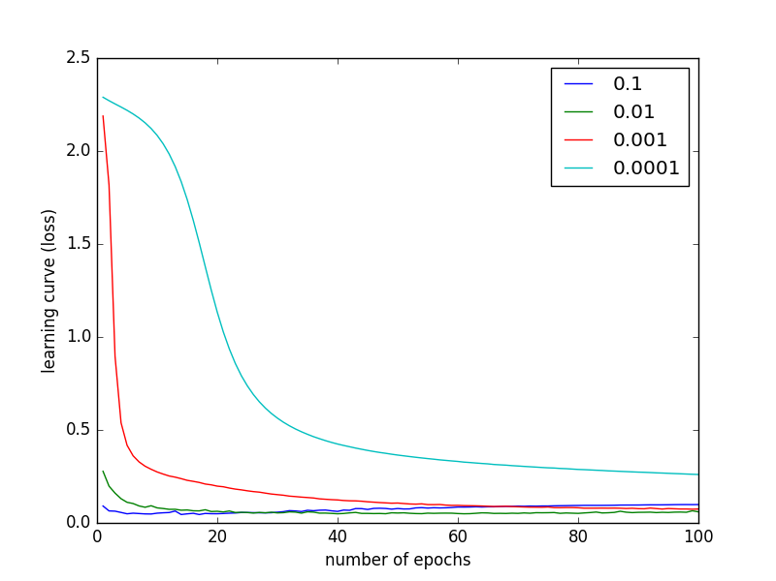

As can be observed from the results in the case of MNIST dataset as the learning rate value decreases so does the ability of network to get better loss in fewer number of epochs. This means we need to let the network run for more epochs to get similar results as higher values for learning rate. This can be interpreted as getting stuck in local minimas in with smaller learning rates.